COTERIE
Website Development Process
Karina Tam · Birmingham City University · FA6138

A documentation of the design and build process behind the Coterie public website — from the original idea through to the final published pages.

STAGE 01
Initial Concept
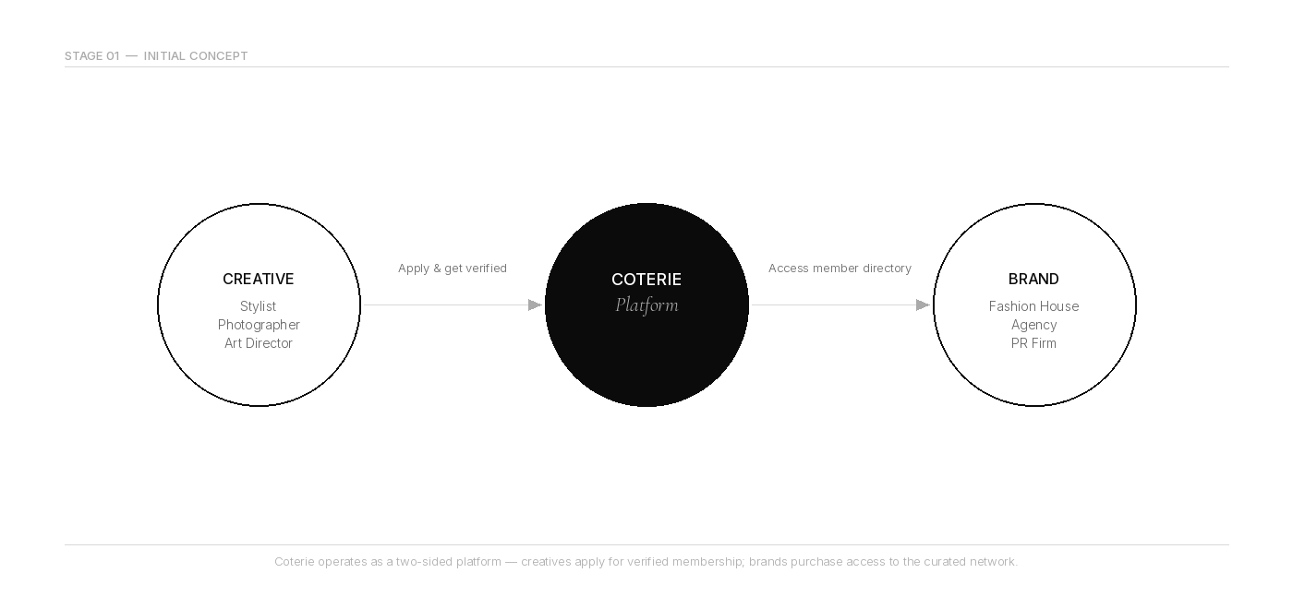
The starting point for Coterie was a frustration. If you work in fashion — as a freelance stylist, a photographer, a casting director, or an art director — the ways to find work have not really changed. You rely on word of mouth, you send cold emails, you hope someone passes your name along. LinkedIn exists but it was never built for this world. Agencies exist but they take a cut and they gate-keep. There was no space built specifically for senior, verified fashion creatives where the platform itself understood the industry.
The idea behind Coterie was to fill that gap. A private, application-only network that connects senior creative professionals in fashion with the luxury brands, agencies and PR houses that need them. The model was built on trust and verification — you cannot just sign up. You apply, you submit credentials, your work history gets reviewed, and you either get accepted or you don't. That exclusivity was not a gimmick. It was the whole point.
On the brand side, the same logic applied. A luxury fashion house does not want to post a casting call publicly. They want access to a curated directory of verified talent, the ability to post a brief privately, and an introduction made through the platform — not just a name and a phone number.
"The pitch was simple: what if there was a network that treated fashion creatives the way they actually work — with discretion, taste, and real professional context?"
The website needed to represent this idea before anyone even applied. It had to feel like something worth applying to. The visual standard of the site itself was part of the product.
From the beginning, the public pages were defined: a homepage that explained the concept and the value, a How It Works section that laid out the process step by step, a Pricing page for both member tiers and brand access plans, and an FAQ for anyone with questions. The site would also have an Apply flow and a Book a Demo form for brands. Everything pointing toward the same action: join.

STAGE 02
Wireframe / Page Layout
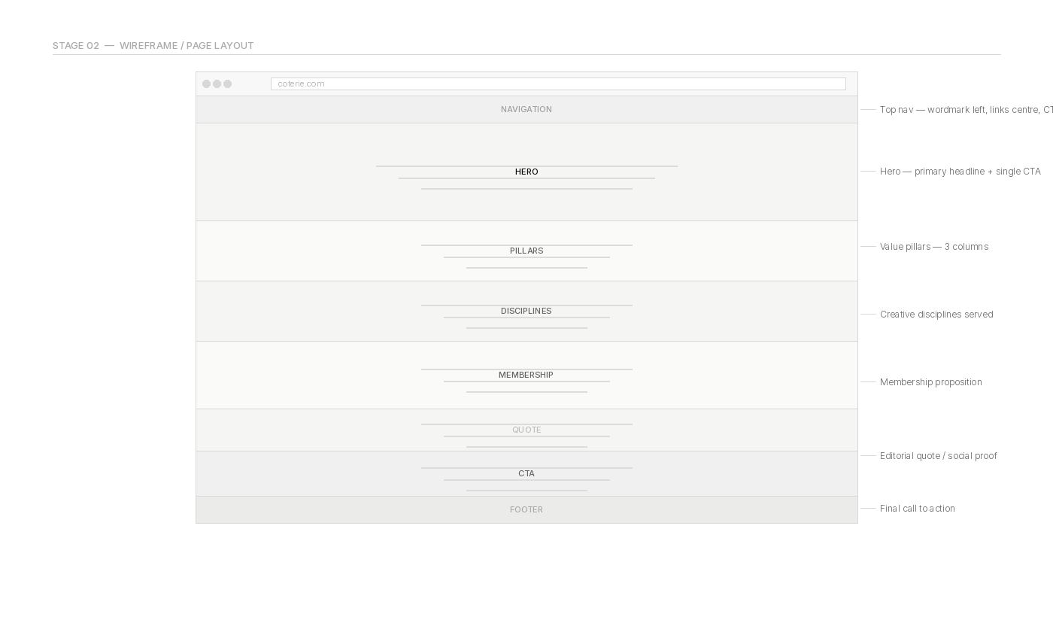
Before any visual design happened, the structure of each page needed to be mapped out. The focus at this stage was not what anything looked like — it was what information needed to be on each page, in what order, and how a visitor would move through the site.
The homepage was the most important to get right. The decision was to build it as a sequence of full-width sections that told the story of the platform from top to bottom. The rough order that emerged early on was: a hero statement, then the core value pillars, then the creative disciplines the platform serves, then membership details, then a scarcity or social proof moment, then a final call to action. Not every section made it through to the end, and some were reordered, but that spine stayed consistent.
A reusable Section component was planned from the start. Every page block would share the same padding system, the same maximum width, the same layout logic. This meant that instead of styling every section individually, the spacing and containment would be inherited — and if it needed to change globally, it only needed changing in one place.
The Pricing page was laid out as a comparison structure — two or three tiers for members, and a separate track for brands. Each tier would show the key benefits, the price point, and a call to action. The FAQ page would use an accordion-style stepper, showing one answer at a time to avoid overwhelming the page with text.
Navigation was planned as minimal: a top bar with the wordmark on the left, links in the centre, and a primary CTA on the right. No dropdown menus, no complex hierarchy. The whole site would be navigable in two clicks from anywhere.
"The wireframe stage was mostly done in notes and rough sketches rather than formal tools. The goal was not a polished prototype — it was just making sure the logic of each page made sense before writing a single line of code."
One layout decision that came early was separating content about creatives from content about brands. The homepage would speak to both but the tone would be led by the creative membership proposition. The brand pitch would live on a dedicated Brands page. This avoided the homepage trying to do too much and losing its focus.

STAGE 03
User Interface Design
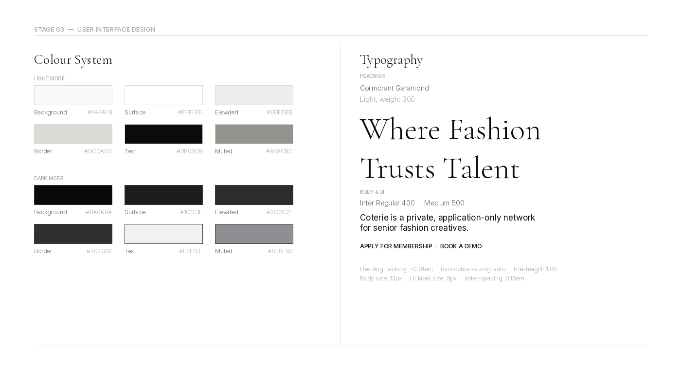
The UI design stage was the longest and the most iterative. The initial instinct was to go clean and minimal, but the first attempts were not quite right — things looked clean on paper but felt generic on screen. The fonts were the biggest issue early on.
The initial heading font choice was Cormorant Garamond, which is a beautiful typeface but one that can quickly look cheap if used carelessly. The first version had headings running at 100 to 120 pixels with very thin letter-spacing and negative tracking. On screen it looked wispy. It looked like a wellness brand or a generic fashion startup trying to look expensive rather than something that actually was. It had to change.
"The feedback at this point was blunt: the fonts looked tacky. Which was the right call. Reducing the heading size to between 56 and 80 pixels, removing the negative tracking, and adding optical sizing made an immediate difference. The same typeface, used differently, went from feeling cheap to feeling considered."
The reference point for the aesthetic was The Row — the brand founded by Mary-Kate and Ashley Olsen. Not to copy it, but to understand the principles. What makes The Row feel the way it does on screen is not any single design choice. It is the accumulation of restraint. No labels sitting above headings introducing what you are about to read. No section dividers breaking the page into boxes. No tinted backgrounds differentiating one block from another. Just text, space, and proportion.
A research document was produced to formalise the design system before it was built. This pinned down the exact colour values for both light and dark modes, the font weights, and the spacing logic. For light mode: a warm off-white background at #FAFAF8, a slightly warmer elevated surface at #EDEDEB, and near-black text at #0B0B0B. For dark mode: the Apple system grey stack — #0A0A0A background, #1C1C1E surface, #2C2C2E elevated surfaces. These were not arbitrary choices. The warm off-whites stopped the site feeling clinical. The Apple greys in dark mode gave it a quality that matched what users see in high-end native apps.
Typography was also formalised at this stage. Cormorant Garamond at weight 300 for all headings, with optical sizing enabled and positive letter-spacing at 0.01em. Inter at weight 400 for body copy, weight 500 for labels and interface text. An early mistake was setting everything to Inter 300 globally, which made body text look anaemic. The research document specified 400 for body and 500 for UI elements. Fixing that single rule changed how readable the whole site felt.
The colour token system was built as CSS custom properties — named variables like --c-bg, --c-surface, --c-elevated, --c-border, --c-text, and --c-muted — that switched values depending on the active theme. This meant the same component worked in both light and dark mode without any duplication.
The btn-primary component was designed as a hairline border button — a one-pixel border in the rule colour, transparent fill, and Inter 500 at 9 pixels with wide letter-spacing. No filled buttons anywhere on the public pages. The effect was intentional restraint: a CTA that felt like an invitation rather than a demand.
Screenshots of The Row, Lemaire, Toteme, and Jil Sander were used as visual references throughout this stage. Not to replicate them, but to calibrate. If a design decision would have looked wrong on one of those sites, it probably needed reconsidering.

STAGE 04
Prototype Development
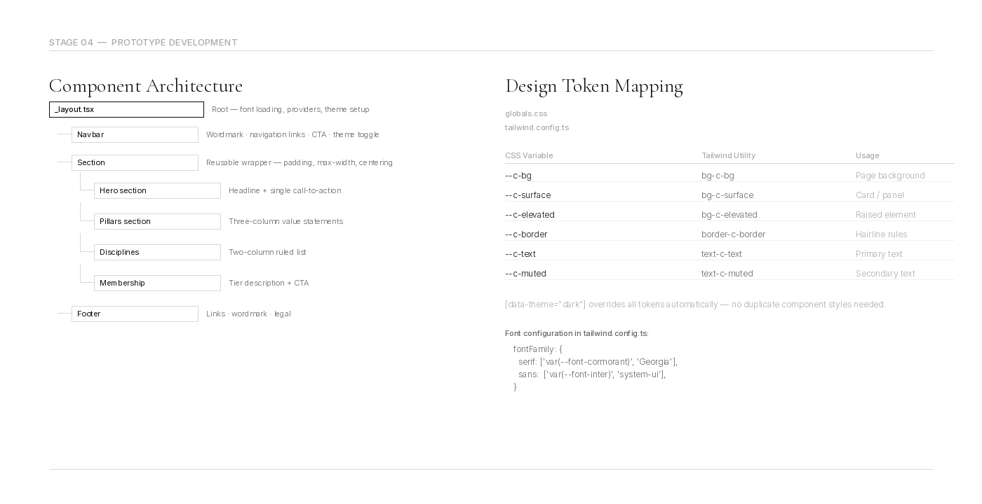
The prototype was built in Next.js using Tailwind CSS as the utility framework. The choice of Next.js was driven by the need for a performant, production-ready foundation — the site needed to be fast, SEO-friendly, and easy to expand into authenticated sections later when the full app was ready.
Tailwind was configured with a custom theme extension that mapped the design tokens from the research document into utility classes. The font families were mapped — font-serif pointing to Cormorant Garamond, font-sans to Inter — so that every heading could use font-serif in the markup without hardcoding font family names anywhere. The colour tokens were mapped similarly, so bg-c-bg, text-c-text, border-c-border and so on became available across the whole codebase.
The Section component was one of the first things built. It wrapped every page block and handled all the vertical padding, the max-width constraint, and the horizontal centering. It accepted a size prop — sm, default, lg, hero — that controlled how much breathing room each section got. Once this component existed, adding new page sections became much faster because the layout logic was already handled.
The prototype was run locally using the Next.js development server. Each page was built in isolation first — the homepage, then pricing, then FAQ — before being connected through the navigation. This made it easier to spot layout problems on individual pages without being distracted by the full site context.
"One of the most useful moments in the prototype stage was seeing the homepage in a browser for the first time. Things that looked fine as code choices suddenly felt wrong at scale. The section borders were the first thing that had to go."
The original Section component had an optional border prop that added a top border to separate sections from each other. In a wireframe context this seemed sensible. In the browser it made the page feel like a set of stacked cards rather than a continuous piece of writing. Removing the borders and letting whitespace do the separation work was one of the most impactful single changes made during prototyping.
The Stepper component — used on the FAQ page and originally on the homepage — also went through revision during this stage. The initial version used a filled background on the active step, which created a heavy visual block. Removing the fill so that only the border-bottom changed on activation made it feel lighter and more in keeping with the rest of the site.
Font loading was handled through Next.js font optimisation. Cormorant Garamond was loaded with weights 300, 400, and 500, and Inter was loaded in the same configuration. Both were injected as CSS variables on the HTML element, which is the pattern Next.js recommends for avoiding layout shifts on load.
Dark mode was implemented using a data-theme attribute on the HTML element, toggled by a button in the navigation. All colour tokens were defined under [data-theme="dark"] overrides in the global stylesheet, so switching themes required no JavaScript beyond setting the attribute.

STAGE 05
Implementation
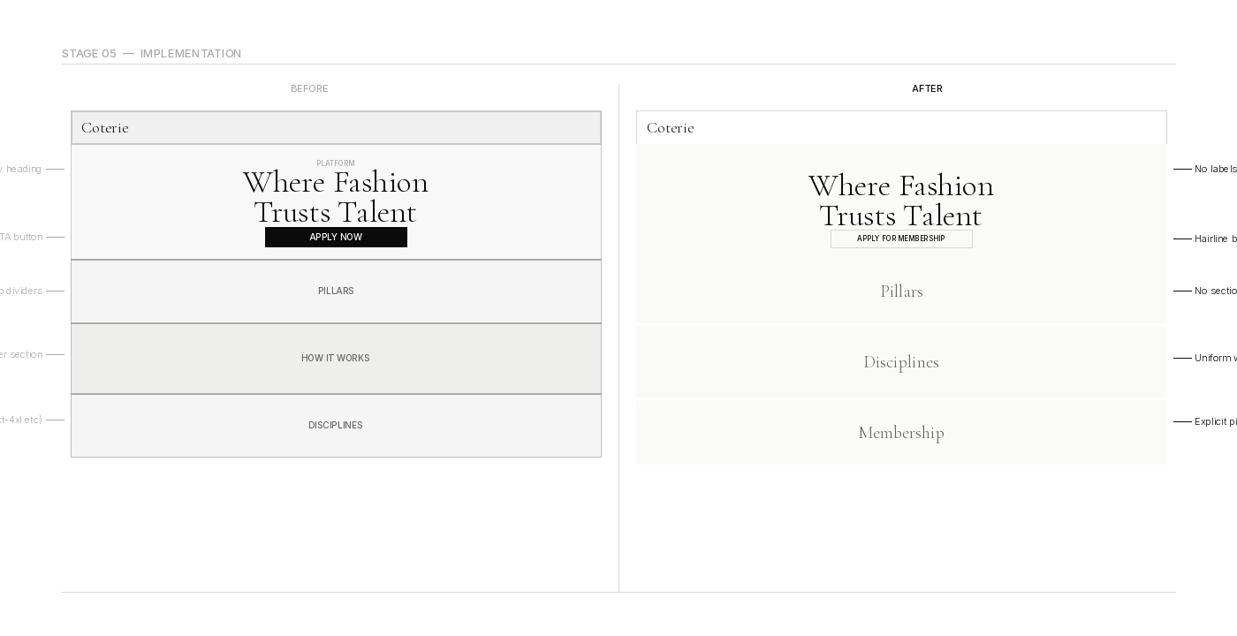
The implementation stage was where the gap between the design vision and the built reality got closed. This involved a combination of new feature work, refinement of what had already been built, and systematic cleanup of inconsistencies that had accumulated during prototyping.
One of the most significant cleanup tasks was removing utility classes that conflicted with the design system. Tailwind classes like font-normal, font-medium, and font-light had been added to individual components at various points during development. These overrode the weights set in the global stylesheet and caused inconsistencies — some headings were appearing heavier than intended, some body copy was lighter than it should have been. A batch find-and-replace pass across all public page files removed these overrides and let the global styles take over.
Body text size was also standardised at this stage. The initial implementation had used text-[15px] across several pages. The research document specified a smaller, more restrained body size. All instances were updated to text-[13px], which brought the type scale more in line with the editorial references that had informed the design.
The heading sizes were revisited on every public page. Classes like text-4xl and text-5xl were replaced with explicit pixel values — text-[36px] and text-[44px] — to ensure exact control over the type scale without relying on Tailwind's default scale, which was too coarse for this level of typographic detail.
Background tints on sections — bg-c-surface/40 applied to certain Section classNames — were found and removed. These had been added at various points to create visual differentiation between sections. But they worked against the clean, continuous feel that the design was aiming for. Once removed, the pages felt more coherent.
The pricing page went through a significant revision during implementation. The highlighted tier card, which had been using a filled bg-c-elevated background to stand out, was flattened. The CTA button on that tier, which had been a solid black filled button, was replaced with the standard btn-primary hairline border style. The Most Popular label was stripped of its background tint. These changes brought the pricing page into the same visual register as the rest of the site.
"Every time something was removed — a border, a background, a font-weight class — the page looked better. The implementation stage became as much about subtraction as it was about addition."
The homepage was the last major page to be finalised. It was rebuilt from scratch rather than incrementally patched, because the accumulated decisions from early prototyping had made the file difficult to work with. The rebuilt version had five clean sections: the hero, the pillars, the disciplines, the membership section, and a closing editorial quote with a final CTA. No Stepper on the homepage. No FAQ. No labelling above headings. Just the content, in sequence, with whitespace.
Font optical sizing and text-rendering optimizeLegibility were added to the heading styles in the global stylesheet during this stage. These are CSS properties that most frameworks do not enable by default, but they make a noticeable difference to how Cormorant Garamond renders on screen, particularly at smaller display sizes. The optical sizing allows the font to adjust its letterform proportions for the size it is being displayed at, which is the difference between a heading that looks typeset and one that looks like it was just scaled up.

STAGE 06
Final Website
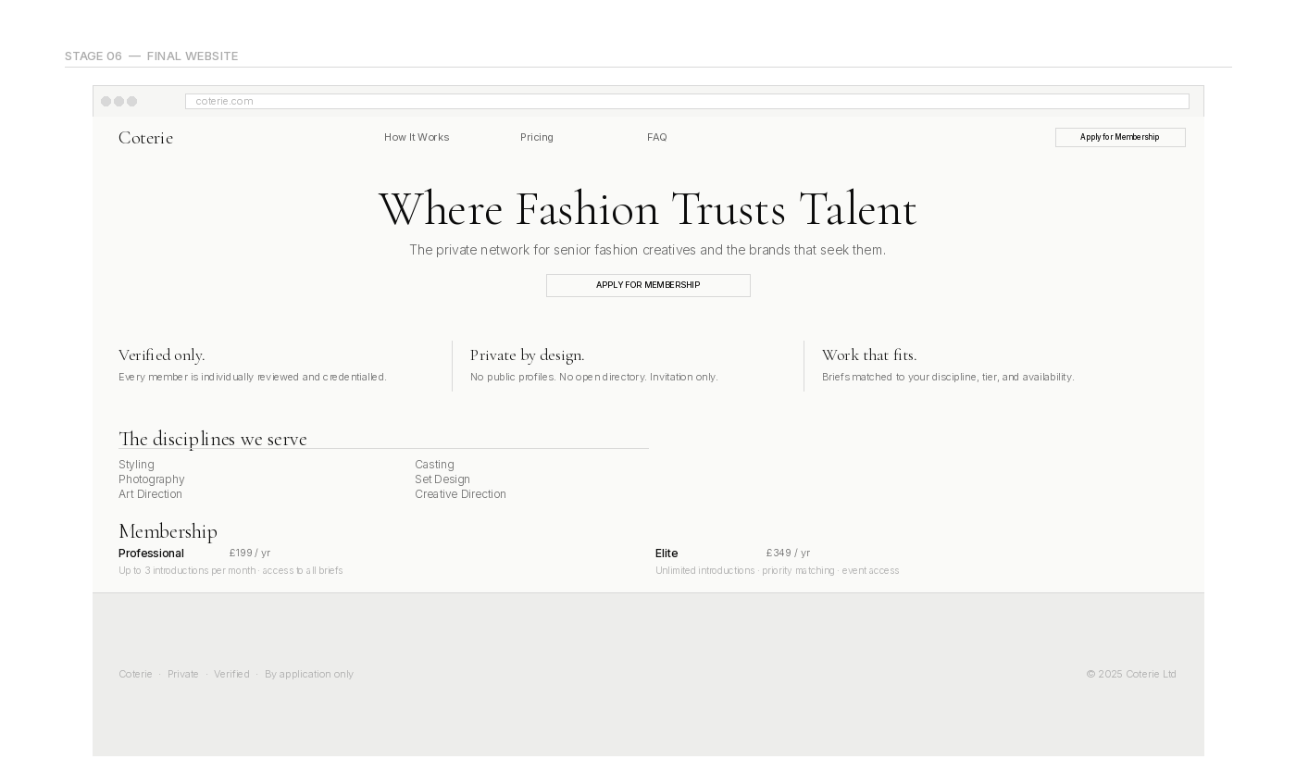
The final website is a multi-page public-facing site built in Next.js, styled with Tailwind CSS and a custom design token system, and designed to a standard that reflects the exclusivity and taste-level of the platform it represents.
The homepage opens with a full-height hero section carrying the primary headline and a single CTA. Below it, the site moves through a series of spacious sections — the creative disciplines the platform serves, the membership proposition, a scarcity quote, and a final call to apply. There are no section borders. There are no labelled headers above headings. There are no background fills. Whitespace and typography carry all the visual work.
The Pricing page presents the membership tiers and the brand access plans clearly and without visual noise. No filled highlight cards. No solid CTA buttons. The structure communicates value through copy and proportion rather than visual emphasis tricks.
The FAQ page uses the Stepper component to surface one answer at a time. The active step is indicated through a bottom border change only — no fill, no background, no colour shift in the text. The typography does the indicating.
Both light and dark modes are fully implemented and correct. Light mode uses the warm off-white palette from the research document. Dark mode uses the Apple system grey stack. The transition between them is instant and coherent across every element on every page.
"The final version of the site is something that could sit alongside the digital presence of the brands it is trying to attract. That was always the standard it needed to meet."
The typeface pairing — Cormorant Garamond at weight 300 for display headings, Inter at weight 400 for body and 500 for interface elements — holds up across all viewport sizes and both themes. The heading sizes are conservative by fashion-site standards: 56 to 80 pixels at the largest, with positive letter-spacing and optical sizing enabled. The effect is confident rather than decorative.
The design system is fully token-based and easy to maintain. Changing the brand colour, adjusting the border weight, or updating the elevated surface shade in either theme is a single change in the global stylesheet that propagates everywhere. The component library — Section, Button, Stepper, Footer — is consistent and composable.
The website works as both a standalone public presence and a front door to the wider product. Someone who lands on it from a referral, a press mention, or a social link should immediately understand what Coterie is, why it is different, and what they need to do next. The navigation is simple enough that nothing gets in the way of that.
Taken together, the site is a product that earns the trust of the people it is trying to recruit — senior creative professionals who have worked with the best houses in the industry, and luxury brands with high standards for the tools and platforms they use. The design had to be good enough to be taken seriously by both.

Coterie · Karina Tam · Birmingham City University · FA6138

